# Project Design Phase-I

# Solution Architecture

|  |  |
| --- | --- |
| Date | 19 September 2022 |
| Team ID | PNT2022TMID54166 |
| Project Name | University Admit Eligibility Predictor |
| Maximum Marks | 4 Marks |

**Solution Architecture:**

Solution architecture is the process of developing solutions based on predefined processes, guidelines and best practices with the objective that the developed solution fits within the enterprise architecture in terms of information architecture, system portfolios, integration requirements and many more.It can then be viewed as a combination of roles, processes and documentation that are intended to address specific business needs, requirements or problems through the design and development of applications and information systems.

Solution architecture is the initial step taken when an organization aims to create a set of enterprise solutions, applications and processes that integrate with each other in order to address specific needs and requirements and that often lead to software architecture and technical architecture work.

The solution architecture is described in a document that specifies a certain level of vision for all current and future solutions, applications and processes that the organization has. Design and development of solutions and applications then follow the guidelines specified in the solution architecture document to ensure that they conform to set standards that make integration and communication easier, and make the tracking of problems and inconsistencies between solutions easier as well.

# Example - Solution Architecture Diagram:

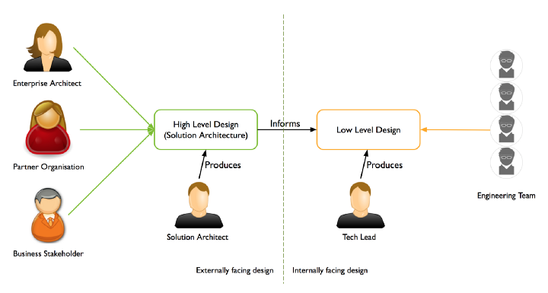

**Reference**[**https://www.techopedia.com/definition/30516/solution-architecture**](https://www.techopedia.com/definition/30516/solution-architecture)